Let’s start with the frequency of two alleles in the population.
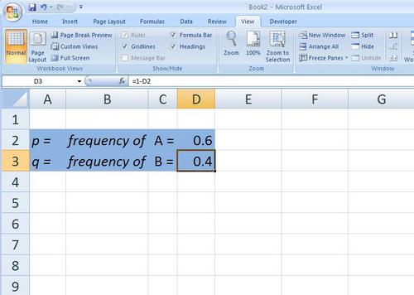
I’ve created a blue zone from A2 to D3—How do you do that? Go ahead and create this blue zone. (Highlight the cells, right click and select format cells) The blue zone on this spreadsheet represents the gene pool–you might want to label this and you can if you wish in row 1.
Note that the value for p is entered in cell “D2″ and the value for q is calculated by a formula in cell “D3″. Make sure you enter a formula to calculate the value for q. [=(1-D2)] Don’t forget to label these cells.
According to our model, the gene pool is assumed to be infinite and the selection for gametes for the next generation is assumed to be random. To accomplish this in the spreadsheet we call on the RANDOM function. Let’s see how it works. If you were to pick an empty cell on the spreadsheet and enter the following function: [=RAND()] What do you get? Hit the F9 key (manual recalculation) several times and tell me what you get. (a random number returned that was somewhere between 0 and 1.) Our entire model is going to be based on this RANDOM function.
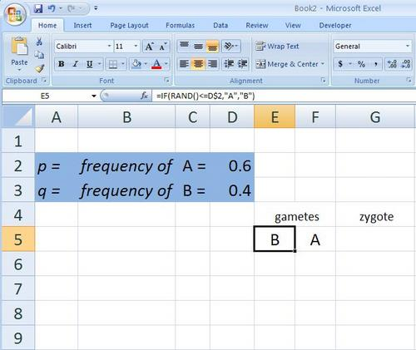
In cell “E5″ let’s generate a random number, compare it to the value of p, and then place either an “A” gamete or a “B” gamete in the cell. We’ll need two functions to do this: The RANDOM function and the IF function. The smart thing would be to have you look this up but I think we’ll just put this into the spreadsheet.
Note that the function that is entered in cell “E5″ is: =IF(RAND()<=D$2,”A”,”B”)
Be sure to include the “$” in front of the “2″ in the cell address “D2″ , it will save time later when building on to this spreadsheet.
Which basically says, if a random number between 0 and 1 is less than or equal to the value of p then put an “A” gamete in this cell or if it is not less than or equal to the value of p put an “B” gamete in this cell. “IF” functions and “RAND” functions are very powerful tools when you try to build models for biology. Now create the same formula in cell “F5″–don’t just copy it sideways or if you do make sure that it is formatted exactly like “E5″. When you have this completed then press the “F9″ key on your windows keyboard to force a recalculation of your spreadsheet. If you have entered the functions correctly in the two cells you should see changing values in the two cells. (This is part of the testing and retesting that you have to do while model building that tends to reinforce the general principles in the learner.)
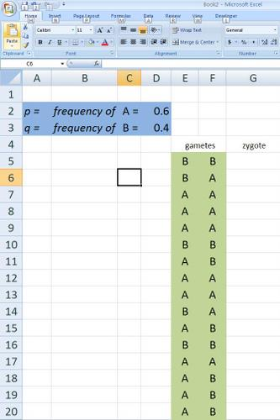
Finally, copy these two formulas down for about 16 rows that will represent 16 offspring for this generation.
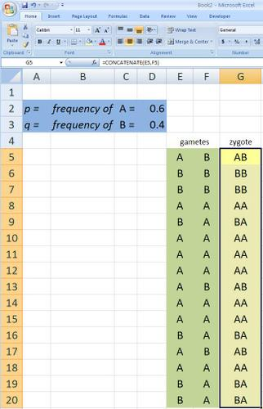
We’ll put the zygotes in cell “G5″ . The zygote is a combination of the two randomly selected gametes. In spreadsheet vernacular you want to concantenate the values in the two cells: In cell “G5″ enter the function:=CONCANTENATE(E5,F5) and then copy this formula down as far down as you have gametes.
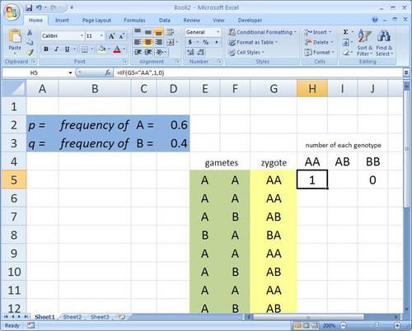
The next columns on the sheet, “H”, “I” and “J” are used for bookkeeping–keeping track of the numbers of each zygote’s genotype. They are rather complex functions that use IF functions to help us count the different genotypes of the zygotes. Here goes:
The function in cell “H5″ is: =IF(G5=”AA”,1,0) which basically states: if the value in cell “G5″ is “AA” then put a 1 in this cell, if not then put a 0.
Enter a very similar function in cell “J5″: =IF(G5=”BB”),1,0)
Can you interpret this formula–what does it say in English? (If the value in cell “G5″ is”BB” then put a 1 in this cell, if not then put a 0.
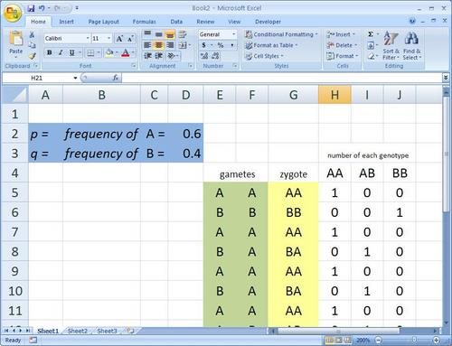
Now let’s tackle the nested “IF” function. This is needed to test for either “AB” or “BA”
In cell “I5″ enter the nested function: =IF(G5=”AB”,1,(IF(G5=”BA”,1,0))
This example requires an extra set of parentheses–something that is necessary to nest functions. This function basically says: if the value in cell “”G5″ is exactly equal to “AB” then put a 1; if not then if the value in cell “G5″ is exactly “BA” then put a one; if it is neither then put a 0 in this cell….
Copy these three formulas down for all the rows you have produced gametes.
Enter the labels for the columns you’ve been working on, “gametes” in cell “E4″, the label “zygote” in cell “G5″, the label “AA” in cell “H4, the label “AB” in cell “I4″, and the label “BB” in cell “J4″
There you have it. Copy the cells “C5″ through “H5″ down for as many zygotes as you’d like in the first generation. Sum up the values in the “F”, “G”, and “H” columns to summarize the genotype frequencies in the next generation, make a histogram and you end up with something like this:
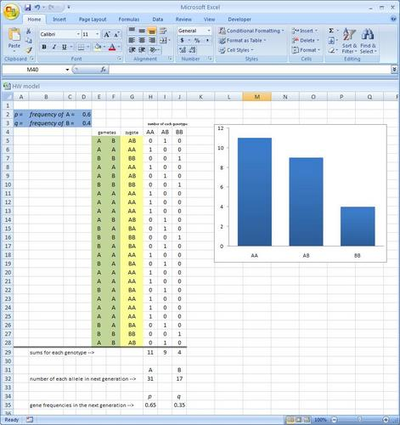
With a model like this you can vary the number of offspring by inserting new rows and copying the formulas or by deleting rows to investigate the effect the size of the population has on the gene frequencies in the next generation.

